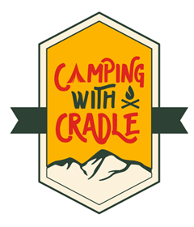

Summer Program Coordinator Intern
At Camping With Cradle, we are committed to making the outdoors accessible for all. Our summer internship contributes to our organizational culture, bringing in fresh perspectives and early-career talent to shape the future of the outdoor industry. As an intern, you’ll contribute to meaningful projects and make a real impact on our participants. Our outdoor work environment allows you to thrive remotely while connecting in person with our Board and volunteers during key activities.
Program Details
- Duration: 13-week internship from May 4 – July 31, 2026
- Schedule: Part-time (25 hours/week)
- Work Environment: Hybrid – remote work in Charlotte with onsite camping/hiking events at NC State Parks
- Residency Requirement: Interns must reside in Mecklenburg County for the duration of the program
- Experience: Hands-on project work that supports our participants and strengthens communities across North Carolina
- Mentorship: Interns are paired with CwC Volunteers and receive feedback to support their development

What You’ll Do
Join Camping with Cradle, the mentoring program that is a means for young adults to become more familiar with the outdoors. As an intern, you’ll support our outdoor camping/hiking outings, gaining exposure to youth development and helping build your social media content skills. You’ll collaborate with our Founder and volunteers and contribute to work that drives real change in healthcare.
What You Bring
- Currently enrolled in a degree seeking academic program, ideally in Outdoor Education/Leadership, Environmental Studies, Wildlife Biology, Parks and Recreation Management, etc..
- Strong curiosity, drive, and ability to work independently and collaboratively
- Excellent time management and communication skills

Bonus Points
- Experience with Social Media/Content Creation, Video Editing and Content Marketing/Strategy
- Prior internship or project experience in Parks and Recreation
- Familiarity with hiking, backpacking and camping

How to Apply:
- Fill out application [link on website] and send resume to keith@campingwithcradle.rg
Compensation:
- $7,800
Recruitment Timeline:
- Applications: February 1, 2026 – March 25, 2026
- Interviews: April 2026
- Offer: Mid-April 2026

